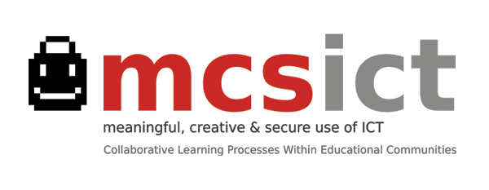
Evaluation processes / Global Proposal (May 2013)
Portfolio
Over the entire life-cycle of the project Activities Report + Post (lively) narrative or depiction Ana Cortinas

Participant Evaluation Feedback
After every meeting or training session Close and Open questions to gather opinions and suggestions Ana Cortinas
Qualitative Evaluation
1. Initial / February 2013: Video recording with opinions (students, teachers and families) Maribel
about ‘Meaningful’, ‘Creative’ and ‘Secure’ Use of ICT.
2. In progress / May-June 2013: Group Reflection in each School and in local coordination group Maribel & Evaluation
following assessment guide. (Meant to make us aware of our Committee
processes /opportunity for establishing changes or adjustments)
International session: Second visit to Madrid May 2013 (short guide) Maribel / Carolina
3. Final / May 2013 Not defined (yet)

Compulsory Steps:
Intermediate report / June 2013 In standby until next week meeting with National Agency Ana Cortinas
‘Products’ and others / June 2014 Not defined (yet)
Criteria Quantitative / Qualitative
School year 2013-2014 Numerical data gathered around defined criteria Giacomo

