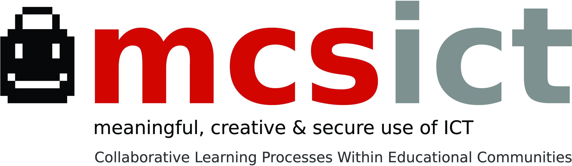
Transnational Meeting in Parma
April 20th – 24th , 2012

Agenda | Notes
Saturday 20th
Arrival in Parma | I don’t know when you will arrive but I could meet you at the hotel and have a dinner with you.
Sunday 21st
Free Time in Parma | To be defined: do you want to have a guided vist of the city centre ? If you agree we can organize it in collaboration with Simonetta
Dinner in Parma | Teachers will join us for having dinner together.  Place to be defined, max € 25.00
Monday 22nd
8.30 Meeting at the hotel and transfer to Fontanellato
9.00 – 12.30 Visit of IC Fontanellato | Teachers and pupils will show works developed in the context of collaborative and creative use of ICT. After the visits in classrooms (both primary and lower secondary classrooms), teachers will have opportunity to share views and opinions with local colleagues
13.00 Lunch in Fontanellato | Lunch at Ristorante Europa € 13.00)
14.30 Return to Parma and free time
17.30 Conference at IC Ferrari about pedagogical and legal aspects related to safe use of ICt in classrooms | Teachers and parents will take part in this event where, with the aid of two external experts, we’ll address issues related to safe use of ICT ( especially internet) in classrooms. Simultaneous translation will be provided
20.30 Dinner in Parma | We’re arranging a dinner in Pizzeria. Max € 20.00 per person
Tuesday 23rd
8.30 Meeting at the hotel
9.00 – 12.00 Visit to Liceo Bertolucci | Liceo Bertolucci it’s an upper secondary school ( students aged between 13 and 19 years) where the greatest part of the classrooms are equipped with Interactive WhiteBoard and where a lot of project based on intensive use of ICT are implemented
13.00 Lunch in Parma | To be defined
14.30 Working sessions | Working sessions about Webpage, Teachers Training and Contents .
20.30 Dinner in Parma | Corale Verdi

8.15 Meeting at the hotel
9.00 – 12.30 Visit at IC Ferrari | Teachers and pupils will show works developed in the context of collaborative and creative use of ICT. After the visits in classrooms (both primary and lower secondary classrooms), teachers will have opportunity to share views and opinions with local colleagues
12.30 Lunch | Lunch at school
Departure to Bologna Airport

