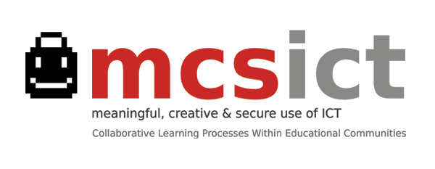
Evaluation processes / Global Proposal (January 2014)
Portfolio
Over the entire life-cycle of the project Activity Report + Post: lively narrative or description Ana Cortinas
Participant Evaluation Feedback
After every meeting or training session Closed and Open questions to find out opinions and suggestions Ana Cortinas
Qualitative Evaluation
1. Initial / February 2013: Video recording with opinions (students, teachers and families) Maribel
about ‘Meaningful’, ‘Creative’ and ‘Secure’ Use of ICT.
2. In progress / May-June 2013: Group Reflection in each School and in local coordination group Maribel & Evaluation
following assessment guide. (Meant to make us aware of our Committee
processes /opportunity for establishing changes or adjustments)
First International session: Second visit to Madrid (May 2013) Maribel / Carolina
Italian session: Second visit to Parma (November 2013) Ana Díaz
3. Final / May 2014 Rubrics? A rubric is an attempt to communicate expectations of quality around
a task. Proposal in next International Meeting (Madrid, January 2014)
Compulsory Steps:
Intermediate report / June 2013 (Official procedure) Already sent to National Agency Ana Cortinas
‘Products’, ‘results’, ‘outcomes’ / June 2014 Not defined (yet). For Debate
Criteria Quantitative / Qualitative
School year 2013-2014 Numerical data gathered around defined criteria Giacomo

